README
- Describe the required functionality of the project. Include the screenshots or screencast taken while testing and deploying your dashboard (Step 6) as proof that you have achieved the required functionality.
The purpose of this project was to develop an interactive dashboard for Grazioso Salvare using the Austin Animal Center (AAC) animal outcomes dataset. The dashboard builds upon the CRUD Python module developed in Project One, allowing users to retrieve and filter animal records from a MongoDB database through a visual interface.
The dashboard provides three rescue-type filters: Water Rescue, Mountain or Wilderness Rescue, and Disaster or Individual Tracking. Each filter retrieves dogs that meet specific breed, sex, and age requirements provided by Grazioso Salvare. A Reset option allows users to return to the complete, unfiltered dataset.
The dashboard also includes an interactive data table, a pie chart displaying the distribution of animal breeds, and a geolocation map. The data table supports pagination, horizontal scrolling, and individual row selectin. When a rescue filter is selected, the table and visualizations update to reflect the matching records. Selecting an animal in the table updates the map to display its location.
The dashboard was tested using all three rescue filters and the Reset option. The following screenshots demonstrate the initial dashboard, each filtering option, and the restored dataset after selecting Reset.
Figure 1: Initial Dashboard – Dashboard displaying the unfiltered animal shelter dataset.
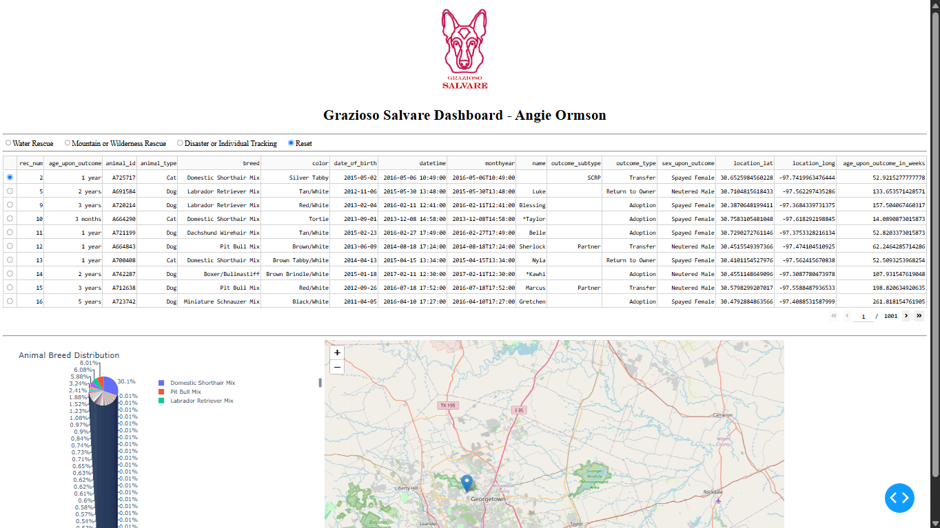
Figure 2: Water Rescue Filter – Dashboard displaying dogs meeting the Water Rescue criteria.
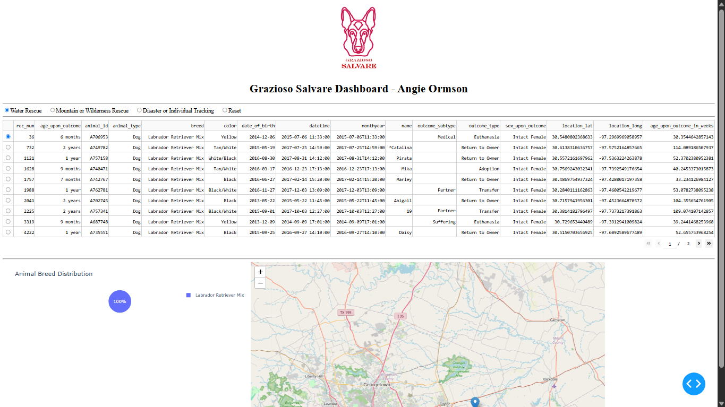
Figure 3: Mountain or Wilderness Rescue Filter – Dashboard displaying dogs meeting the Mountain and Wilderness Rescue Filter.
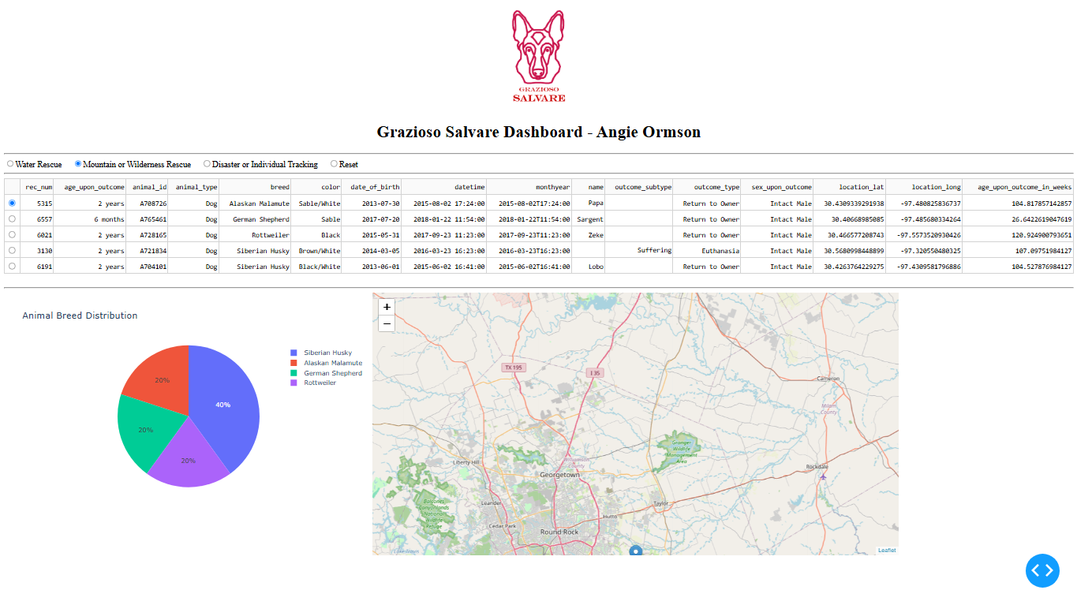
Figure 4: Disaster or Individual Tracking Filter – Dashboard displaying dogs meeting the Disaster or Individual Tracking criteria.
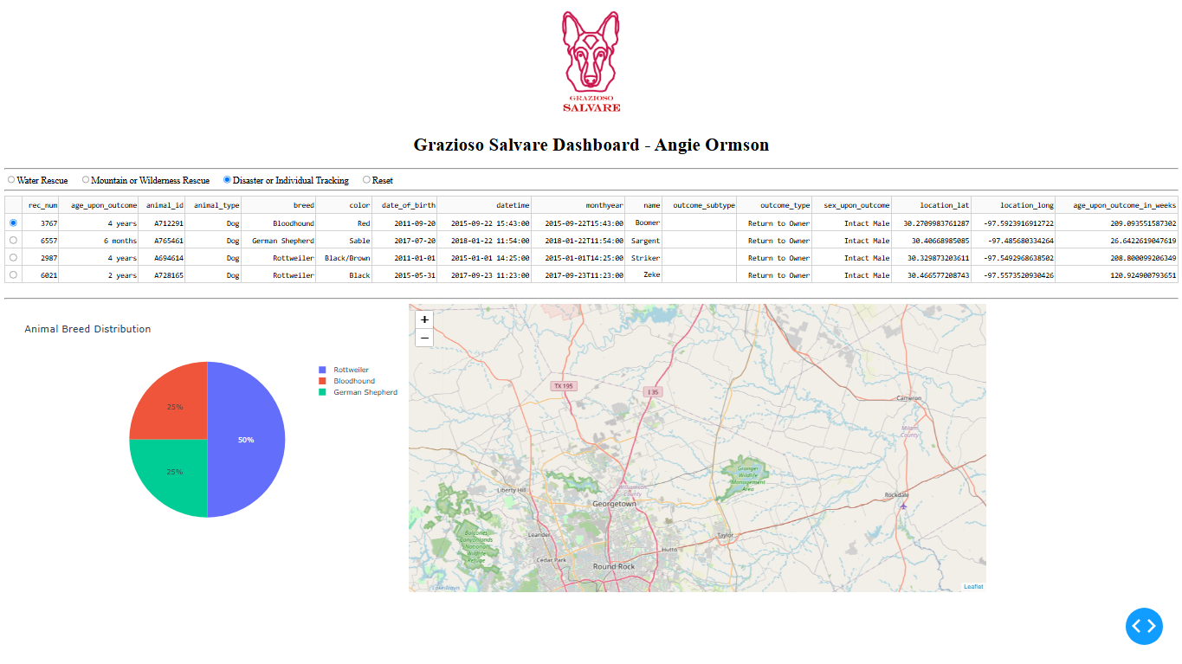
Figure 5: Reset Filter – Dashboard displaying the complete animal shelter dataset after resetting the filters.
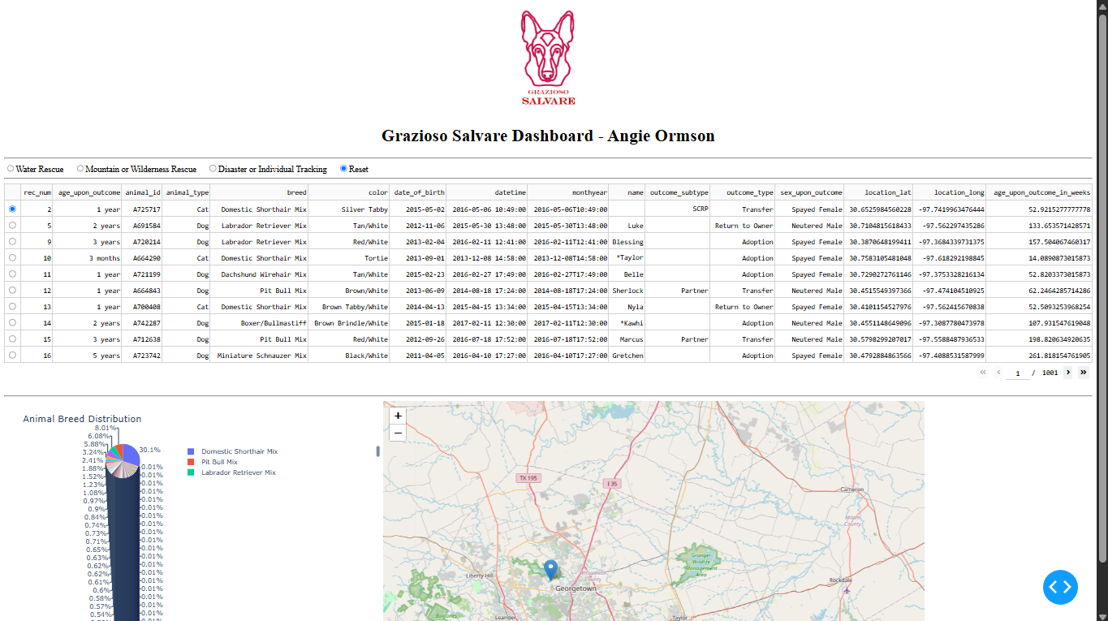
- Describe the tools used to achieve this functionality and a rationale for why these tools were used.
Several tools and technologies were used to develop the Grazioso Salvare dashboard, each serving a specific purpose in retrieving, processing, and displaying animal shelter data.
  - MongoDB was used as the database management system and serves as the model component of the dashboard's Model-View-Controller (MVC) architecture. MongoDB stores the Austin Animal Center dataset as documents and allows animal records to be retrieved using queries based on breed, sex, and age. Its document-based structure makes it suitable for working with the animal shelter records.
  - Python and the CRUD Python Module were used to connect the dashboard to MongoDB. The AnimalShelter class developed in Project One provides the database operations needed to access the records. For this project, the read() method retrieves animal information based on the selected rescue criteria. Reusing the CRUD module also separates database operations from the dashboard's interface.
  - Dash was used to create the interactive web dashboard. Within the MVC architecture, Dash provides the view through its layout components and supports the controller through callbacks. These callbacks respond to user interactions, such as selecting rescue filters or choosing an animal from the data table, and update the displayed information.
  - Pandas was used to convert MongoDB query results into DataFrames, making the records easier to organize and display in the interactive data table.
  - Plotly Express was used to create the breed distribution pie chart. This visualization allows users to compare the proportions of different breeds within the selected dataset.
  - Dash Leaflet was used to create the geolocation map. It displays the location of a selected animal using latitude and longitude coordinates from the dataset.
  - JupyterDash and Codio provided the development and testing environment. JupyterDash allowed the dashboard to run from the Jupyter notebook, while Codio provided access to the Python environment and MongoDB database used throughout the project.
  - Together, these tools support the MVC design by separating data storage and retrieval from the dashboard's presentation and interactive functionality.
- Explain the steps that were taken to complete the project.
The development of the Grazioso Salvare dashboard began by reviewing the project requirements and Dashboard Specifications Document to identify the necessary functionality. The specifications provided the preferred dog breeds, sex, and age ranges for each rescue category, along with the required dashboard components.
The first step was to connect the dashboard to the MongoDB database using the AnimalShelter CRUD Python module developed in Project One. The module's read() method was used to retrieve records from the Austin Animal Center dataset. These records were converted into a Pandas DataFrame, and the MongoDB _id field was removed to prevent compatibility issues with the Dash data table.
Next, the dashboard layout was developed using Dash components. The Grazioso Salvare logo was added with a hyperlink to the Southern New Hampshire University website, and a unique dashboard heading was included. Radio buttons were implemented to allow users to select Water Rescue, Mountain or Wilderness Rescue, Disaster or Individual Tracking, or Reset.
MongoDB queries were then created for each rescue category using the breed, sex, and age requirements from the specifications. Dash callbacks were implemented to connect the radio buttons to the database queries and update the data table when a different filter was selected.
The interactive data table was configured to allow single-row selection, pagination, and horizontal scrolling. A pie chart was created using Plotly Express to display the distribution of breeds within the selected records. A geolocation map was also implemented using Dash Leaflet to display the location of an animal selected from the table.
After the dashboard components were connected, testing was performed in Codio. Each rescue filter was tested to verify that the correct records were returned. The Reset option was tested to confirm that the complete dataset could be restored. Additional testing verified the breed distribution pie chart, geolocation map, and the interaction between selected table rows and map markers.
Finally, screenshots were captured to document the dashboard's functionality. These screenshots demonstrate the initial dashboard, the three rescue filters, and the Reset option. Each screenshot includes the Grazioso Salvare logo and the dashboard's unique identifier.
- Identify any challenges that were encountered and explain how those challenges were overcome.
Several challenges were encountered while developing and testing the Grazioso Salvare dashboard. These challenges involved integrating the existing CRUD Python module, handling dashboard callbacks, displaying the logo, and ensuring the interactive components worked correctly.
One challenge involved connecting the dashboard to the MongoDB database. The starter code referenced a different Python module filename, which needed to be updated to match the CRUD_Python_Module.py file developed in Project One. After correcting the import statement and database credentials, the dashboard was able to retrieve records using the AnimalShelter class.
Another challenge occurred when adding the Grazioso Salvare logo. The dashboard initially produced a FileNotFoundError because the specified image path did not match the file's location in Codio. This was resolved by correcting the file path, allowing the logo to display successfully with a hyperlink to the SNHU website.
The dashboard callbacks also required additional error handling. During development, callbacks could receive empty data or missing selections, which created the possibility of errors when updating the geolocation map or highlighting table columns. Conditional checks were added to handle these situations and prevent invalid row selections from causing the dashboard to fail.
Displaying the complete animal shelter dataset also presented usability challenges because of the large number of records and columns. Pagination was added to display ten records per page, and horizontal scrolling was enabled to make the data table easier to navigate. The breed distribution pie chart also became crowded when displaying the unfiltered dataset because of the number of different breeds represented. However, the chart became more readable when the rescue filters reduced the number of records and breeds displayed.
Finally, testing the dashboard required verifying that the filters, data table, pie chart, and geolocation map responded correctly to user interactions. Each rescue filter was tested against the required criteria, and the Reset option was used to restore the complete dataset. The map was also tested by selecting different animal records and confirming that the location marker updated.
These challenges provided additional experience with debugging Python applications, integrating database operations with interactive components, and improving the usability of a data-driven dashboard.

